CITY OFFICIALS
William Lawrence, City Manager
Maria Carmen Silva, City Clerk
John Scheel, Police Chief Gerald Buhr, City Attorney
COMMISSIONERS
Duane Gardner, Mayor
Sam Fite, Vice Mayor
David Durastanti
Cliff Lunn
N’Kosi Jones

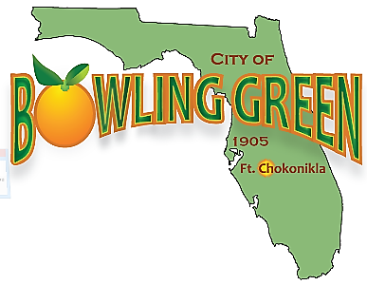

Manager’s Report
01/15/21

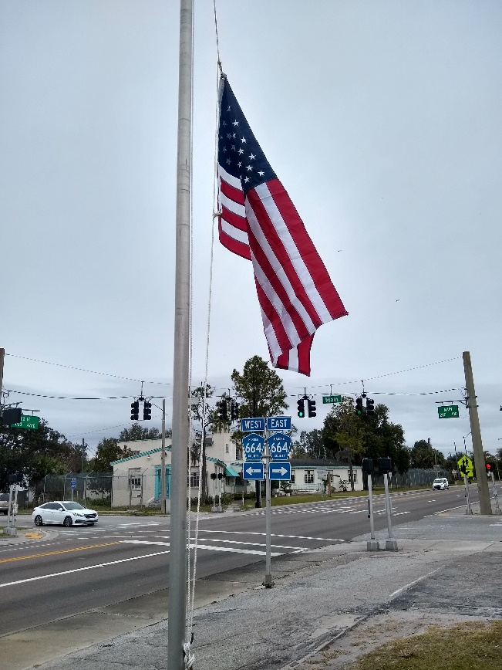
Public Works: New flags were installed by Public Works at City Hall, cemetery, and Pyatt Park. The crew painted the ceiling tiles in the City Hall meeting room. The crew has continued filling potholes and working at the old pool house building.

January 12 Commission Meeting: Newly elected commissioners N’Kosi Jones and Cliff Lunn took their Oath to Office. The Commission denied the fence variance for the property located at 124 Main Street. Jon Solin gave a presentation on his campground development called, Peace River Ranch which will be located on the County Road next to the Peace River. Jon would like to connect his effluent with the wastewater plant. The commission wants to explore the feasibility on this project and report back to them for the February Commission Meeting. A workshop with the new commissioners is scheduled for January 26th at 6:00 pm. to discuss current projects.

Current Projects for 2021

Water Plant Nano Filtration: As builds are being finished and the Nano filtration system has been running for 8 weeks. We should close out by the end of January. $1,200,000 project funded by SRF.
Transmission Line to Wauchula is ready for preconstruction meeting now. Bid awarded to PWC Joint Venture. This is a $1,100,000 project funded 75% funded by SWFMD and 25% SRF Construction ready to start. Roger Homann Pennoni Project Manager
New CDBG grant application has been submitted for Phase II of the sewer plant that includes manholes and lift station upgrades. $750,000 project- Application is in waiting to be awarded.

FDOT SCOP: Road Resurfacing should be going to bid at the end of January. This includes Jones and Church Street. $225,000 project. Roger Homann, Pennoni will be doing the CEI work on the construction phases
A new SCOP grant application will be submitted soon for the 2023 season. Deadline is March
Main Street Park: FDEP program FRDAP Grant for $50,000 was awarded to the city and getting ready for construction. Must be completed by 2023.
Pyatt Park Renovations: We received a $240,000 grant from the Hardee County EDA for park improvements. Kimley-Horn Engineers are currently developing the site plan.
City Hall Flooring: The Front office carpet is being replaced with tile. This project has gone out to bid.
Legislative Appropriations: I have submitted application for $100,000 for an I/I study on our wastewater transmission lines to determine where are leaks care located. It’s costly to treat rainwater at the Wastewater plant.
Peace River Ranch – Wastewater connection

